**Expiriment NO: 6**

**Aim : Familiarisation of linux commands**

**CO2 : Perform system administration task**

**procedure :**

**1)grep**

Grep is used to filter the contents which makes our search easy.



**1.1)grep –v word filename**

Grep-v is used for inverted searching of a content.

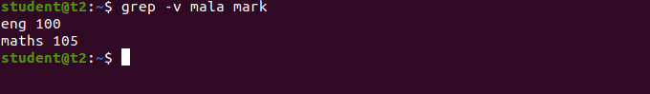

**1.2)grep –A1 word filename**

Grep –A1 is used to display the content along with one line after.

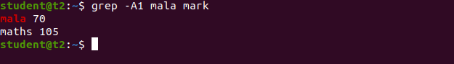

**1.3)grep –B1 word filename**

Grep –B1 is used to display the content along with one line before.



**1.4)grep –C1 word filename**

Grep –C1 is used to display the content along with one line before and after.



**1.5)grep-i word filename**

Used for case insensitive search.



**2)head filename**

Head is used to display the first 10 lines of a file.

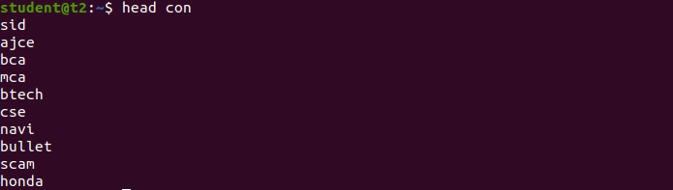

**2.1)head limit filename**

Head – limit is used to display the first set of lines upto the limit.

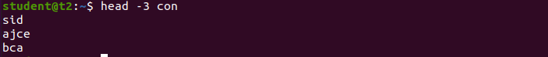

**3.)tail filename**

Tail is used to print the last 10 lines of a file by default.

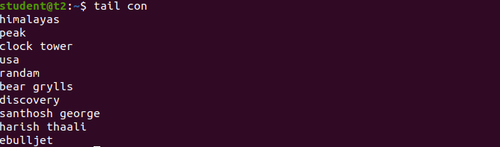

**3.1)tail –limit filename**

Tail –limit is used to display the last set of lines upto the limit.

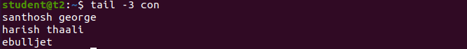

**4)mv filename filename**

Mv command is used to copy the contents from one file to another.

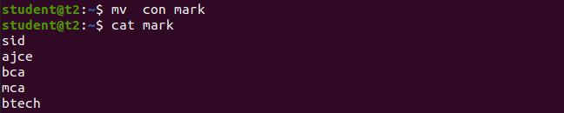

**4.1)mv-b filename filename**

Mv –b used to take a backup before overwriting the contents.

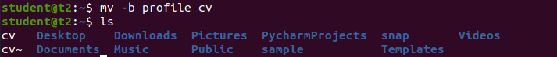

**4.2)mv –i filename filename**

mv-i used to prompt before overwriting.

